**Name: Husnain Momin**

**Course: IICT**

**Section: 1-B**

# **Assignment No. 1**

## **Computer:**

An electronic machine that has the capability of performing computation and processing on the given data is called a computer.

It performs 4 basic operations under a program’s direction and control:

* *Input*
* *Processing*
* *Output*
* *Storage*

Input:

The set of information that we provide to the computer to carry out its necessary tasks is called input.

Processing:

The calculations performed by the computer when we provide it with a set of instructions is called processing.

Output:

The result that we obtain after the given input is processed by the computer is called output. We get information as a result of processed raw data that we input.

Storage:

It is a process through which digital data is saved within a data storage device by means of computing. The output is stored as storage in a *Hard Disk Drive (HDD)* or a *Solid State Drive (SSD).*

These devices usually come preinstalled in computer builds/laptops and can be customized any time suiting the user’s needs.

## **Types of Devices:**

There are 2 types of devices used in a computer:

* *Input*
* *Output*

Input Devices:

The devices used to enter data into a computer are called input devices. E.g. Mouse, Keyboard.

Output Devices:

The devices which convert information into a human-readable form are called output devices. E.g. Printer, Monitor.

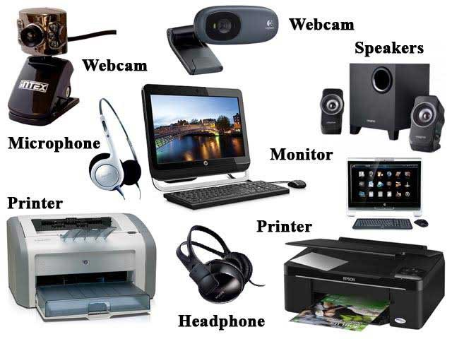

*Figure 1. Input and Output devices*

## **Types of Computers:**

There are several types of computers and some of them are listed below:

* Desktop (PC, Microcomputer)
* Notebook (Laptop)
* Workstation
* Personal Digital Assistant (PDA/Pocket PC)
* There are also ***servers, mainframe computers*** and ***supercomputers***.

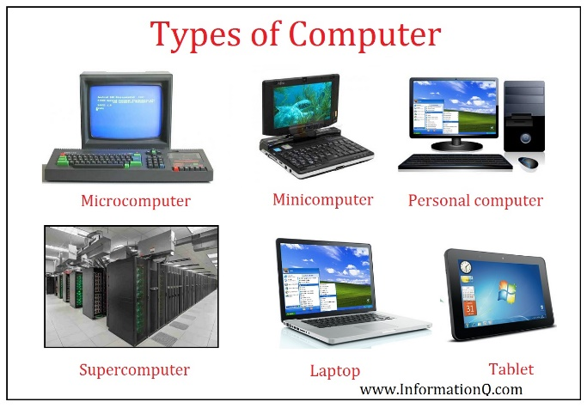

*Figure 2. Types of Computers*

## **History and Generations of Computers:**

History of Computers:

The first mechanical computer, ***The Babbage Difference Engine***, was designed by **Charles Babbage** *(born December 26, 1791, London, England)* in **1822**. He was an English mathematician and inventor. He was also instrumental in founding the Royal Astronomical (1820) and Statistical (1834) societies.

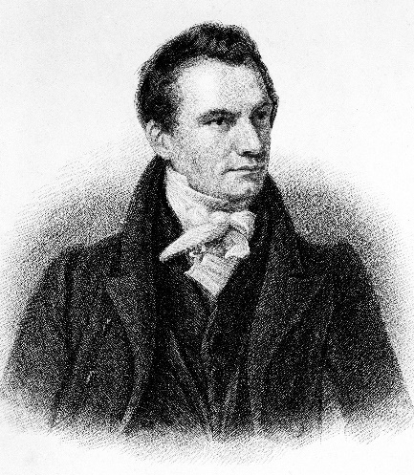

*Figure 3. Charles Babbage*

He is considered as the "***Father of the Computer***". The machine was about a century ahead of its time. All the parts for his machine had to be made by hand which was a major problem at that time. Eventually, the project was dissolved with the decision of the British Government to cease funding. His failure to complete the engine was caused by mostly political and financial issues including his desire to create an extremely sophisticated computer and be ahead of everyone. Nevertheless, his son, ***Henry Babbage***, completed a simplified version of the engine in **1888**. He gave a successful demonstration of its use in **1906**.

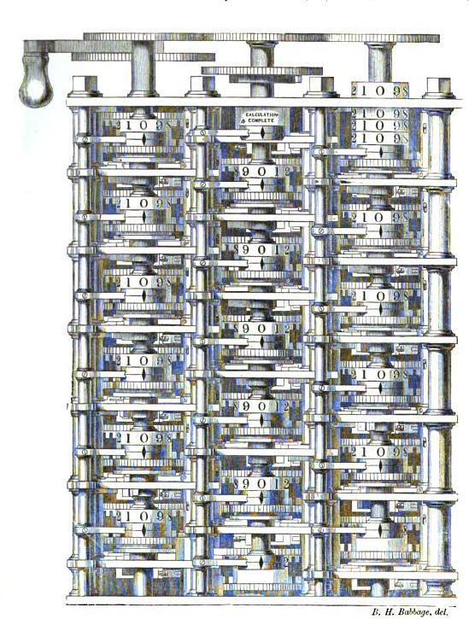

*Figure 4. A portion of Babbage's Difference engine.*

Analog Computers:

In the first half of the 20th century, ***analog computers*** were being used for sophisticated scientific needs and their need kept increasing as time passed by. However, these computers were not programmable and were not as versatile as modern day computers. Some examples of analog computers are *operational amplifiers*, *mechanical integrators* and *electric integrators*.

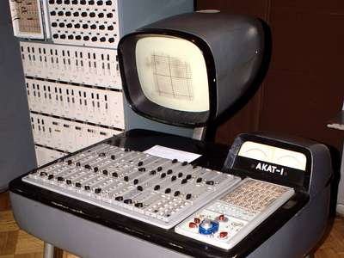

*Figure 5. Analog Computer*

Digital Computers:

By 1938, the United States Navy had developed an electromechanical analog computer. It was named as the ***Torpedo Data Computer***,which used trigonometry to solve the problem of firing a torpedo at a moving target inside a submarine. Similar machines were widely used during WW2. Early digital computers were *electrochemical* and had low operating speeds. They were later overtaken by much faster ***all-electric computers.***

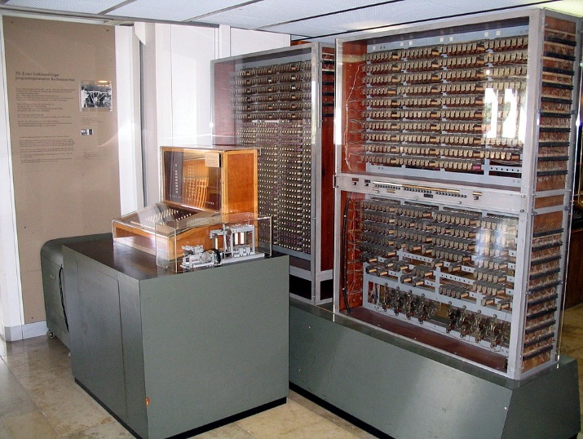

*Figure 6. First Digital Computer*

Modern Computers: 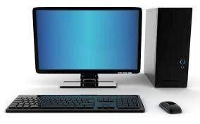

*Figure 7. Modern Computer*

The principle of the modern computer was proposed by ***Alan Turning in 1936.*** Turing proposed a simple device that he called "***Universal Computing machine***". He proved that this machine is capable of computing anything that is computable by executing instructions stored, allowing the machine to be programmable.

## **Generations of Computer:**

There are five computer generations known till date. Below we will be discussing them with their time period.

First Generation:

The period of first generation was from **1946**-**1959**. The computers of first generation used *vacuum tubes* as the basic components for memory and circuitry for CPU (Central Processing Unit). These tubes, like electric bulbs, produced a lot of heat. They were very expensive and only large organizations were able to afford it. The computers in this generation used ***machine code*** as the programming language.

Some computers of this generation were:

* ENIAC
* EDVAC
* UNIVAC
* IBM-701
* IBM-650

Second Generation:

The period of second generation was from **1959**-**1965**. In this generation, transistors were used that were cheaper, consumed less power, and were faster than the first generation of computers. In this generation, magnetic cores were used as the primary memory and magnetic tape and magnetic disks as secondary storage devices. High level programming languages like *FORTRAN, COBOL* were used in this.

Some computers of this generation were

* IBM 1620
* IBM 7094
* CDC 1604
* CDC 3600
* UNIVAC 1108

Third Generation:

The period of third generation was from **1965**-**1971**. The computers of third generation used Integrated Circuits (ICs) in place of transistors. High-level languages (*FORTRAN-II TO IV, COBOL, PASCAL PL/1, BASIC, ALGOL-68* etc.) were used during this generation.

Some computers of this generation were

* IBM-360 series
* Honeywell-6000 series
* PDP (Personal Data Processor)
* IBM-370/168
* TDC-316

Fourth Generation:

The period of fourth generation was from **1971**-**1980**. Computers of fourth generation used Very Large Scale Integrated (VLSI) circuits. Fourth generation computers became more powerful, compact, reliable, and affordable. As a result, it gave rise to Personal Computer (PC) revolution. All the high-level languages like *C, C++, DBASE* etc., were used in this generation.

Some computers of this generation were

* DEC 10
* STAR 1000
* PDP 11
* CRAY-1 (Super Computer)
* CRAY-X-MP (Super Computer)

Fifth Generation:

The period of fifth generation is **1980**-**till date**. In the fifth generation, VLSI technology became ULSI (Ultra Large Scale Integration) technology, resulting in the production of microprocessor chips having ten million electronic components. This generation is based on parallel processing hardware and AI (Artificial Intelligence) software. AI is an emerging branch in computer science, which interprets the means and method of making computers think like human beings. All the high-level languages like *C* and *C++, Java, .Net* etc*.,* are used in this generation*.*

Some computer types of this generation are

* Desktop
* Laptop
* Notebook
* Ultrabook
* Chromebook

## Cache memory and Virtual Memory:

Cache memory:

A cache is a hardware or software component that stores data so that future requests for that data can be served faster. The data stored in a cache might be the result of an earlier computation or a copy of data stored elsewhere.

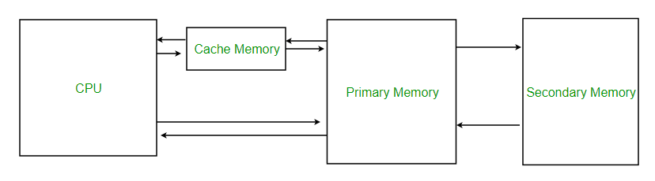

*Figure 8. Cache Memory*

Hardware implements cache as a block of memory for temporary storage of data likely to be used again. Central processing units (CPUs) and hard disk drives (HDDs) frequently use a ***hardware-based cache***, while web browsers and web servers commonly rely on ***software caching***.

When a system writes data to cache, it must at some point write that data to the backing store as well. The timing of this write is controlled by what is known as the ***write policy***.

There are two basic writing approaches:

* **Write-through**: Write is done synchronously both to the cache and to the backing store.
* **Write-back (also called write-behind)**: Initially, writing is done only to the cache. The write to the backing store is postponed until the modified content is about to be replaced by another cache block.

A **write-back cache** is more complex to implement as compared to **write through cache**, since it needs to track which of its locations have been written over, and mark them as dirty for later writing to the backing store.

Since no data is returned to the requester on write operations, a decision needs to be made on write misses, whether or not data would be loaded into the cache. This is defined by these two approaches:

* **Write allocate (also called fetch on write)**: Data at the missed-write location is loaded to cache, followed by a write-hit operation. In this approach, write misses are similar to read misses.
* **No-write allocate (also called write-no-allocate or write around)**: Data at the missed-write location is not loaded to cache, and is written directly to the backing store. In this approach, data is loaded into the cache on read misses only.

Both write-through and write-back policies can use either of these write-miss policies, but usually they are paired in this way:

* **A write-back cache** uses ***write allocate***, hoping for subsequent writes (or even reads) to the same location, which is now cached.
* **A write-through cache** uses ***no-write allocate***. Here, subsequent writes have no advantage, since they still need to be written directly to the backing store.

Some **examples of hardware cache** include CPU cache, GPU cache and DSPs.

**Software caches** include Disk cache and Web cache. There are others as well.

Virtual Memory:

Virtual memory or *virtual storage* is a memory management technique that provides an idealized abstraction of the storage resources that are actually available on a given machine which creates the illusion to users of a very large memory. The computer's operating system, using a combination of hardware and software, maps memory addresses used by a program, called ***virtual addresses***, into ***physical addresses*** in computer memory.

The primary **benefits of virtual memory** include freeing applications from having to manage a shared memory space, ability to share memory used by libraries between processes, increased security due to memory isolation, and being able to conceptually use more memory than might be physically available.

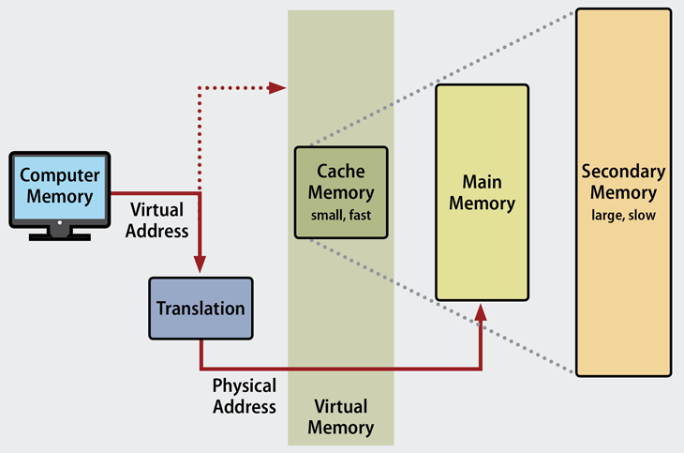

*Figure 9. Virtual Memory*

During the 1960s and early '70s, ***computer memory was very expensive***. The ***introduction of virtual memory*** provided an ability for software systems with large memory demands to run on computers with less real memory. The savings from this provided a strong incentive to switch to virtual memory for all systems.

Most ***modern operating systems*** that support virtual memory also run each process in its own dedicated address space. Each program thus appears to have sole access to the virtual memory.

Limitations of using virtual memory:

* Applications run slower if they are running from virtual memory
* Thrashing can occur if there is not enough RAM, which will make the computer perform slower.
* It may take time to switch between applications using virtual memory.
* It lessens the amount of available hard drive space.